Gucci PR and Communication
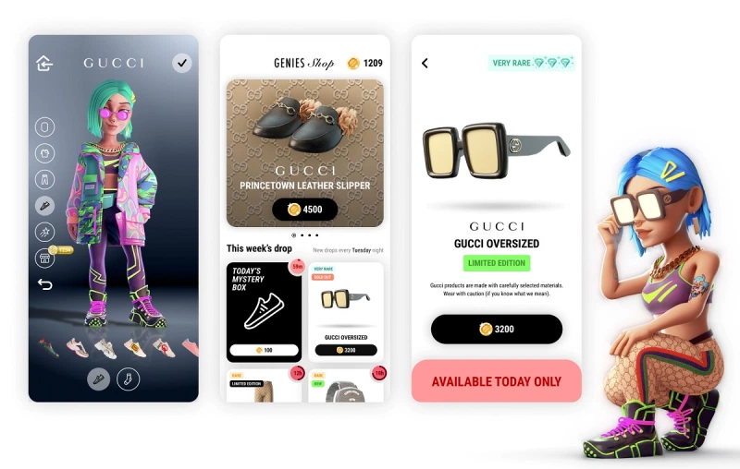
Digital Campaigning
In 2018, Gucci posted #1 in Tribe Dynamic’s digital earned media rankings within luxury brands, earning $56.7 million USD in publicity and engagement (CPP-Luxury, 2018). Their digital campaigning and PR have allowed the brand to create an online presence that has drawn in a younger consumer demographic, developing over the last decade. Their online campaigns include the likes of Winter in the Park featuring Alexa Chung and Vanessa Kirby, as well as Doraemon x Gucci. Winter in the Park used high profile celebrities to target London locals during the pandemic, using the city’s iconic Hyde Park as a location and focusing the campaign around a COVID friendly activity, allowing for an element of relatability for consumers. In doing this, they promoted classic Gucci pieces that were reimagined under Alessandro Michele’s creative direction and created a strong story to appeal luxury Gucci accessories. Doraemon x Gucci celebrated the Luna New Year and also displayed the brands cultural outreach and progressive fashion motivations.
Genies is a tech company that creates personalised 3D avatars, to which Gucci has provided the fashion for them. In a recent found partnership with Giphy, Gucci will also now sell exclusive digital merchandise items to dress avatars in luxury wear. This will provide engagement for consumers that aren’t necessarily luxury buyers and shows Gucci’s digital expansion into new online platforms that also expand their fashion ranges.
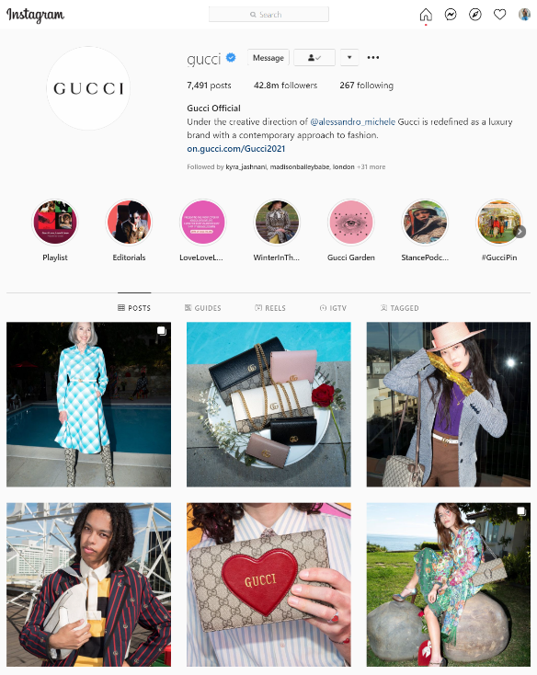
Social media
Gucci also has a substantial social media presence, using new and emerging platforms like Tik Tok and Spotify to appeal to everyday consumers and attract them to their entry level products. In 2020, the #GucciModelChallenge went viral on Tik Tok, causing an unofficial campaign casting that amassed over 7.9 million views (Li, 2020). The trend centered around building a Gucci inspired outfit and gave the brand a sizable platform on one of the biggest social media platforms of the year. Gucci also has a podcast called the Gucci Podcast, with episodes that detail Michele’s collaborations, campaigns, and collections, releasing 1-2 times a month and providing consumers with accessible insight. The brands Instagram also provides promotional strategy, harbouring 42.8 million followers with image driven content and high-quality product imagery. Social media also provides a direct platform for brands to interact with consumers on a daily basis and instantly advertise new products and highlight campaigns.
Celebrity relationships
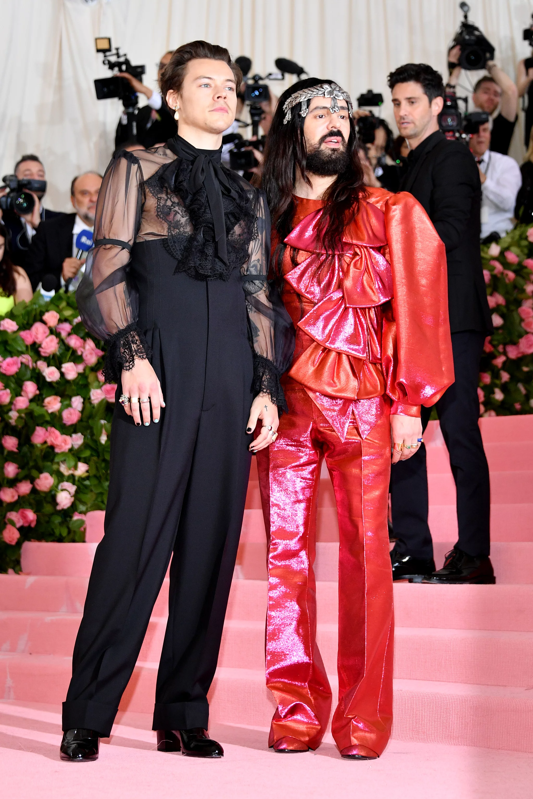
The most prominent muse that has emerged out of Gucci in the last few years is Harry Styles. Styles and Michele have cultivated a mutually beneficial relationship that has allowed for Styles’ fashion conscious fanbase to create consumer interest. The singer has also appeared in campaigns like Gucci Memoire d’une Odeur that was unveiled after the Cruise 2020 fashion show, as well as being the face of the 2018 tailoring campaign and appearing alongside Michele at the Met Gala in 2019. His newfound prominence as the face of Gucci saw him be the first to wear a full menswear look from Michele’s catwalk collection to an awards show, with his music videos incorporating Gucci styling as well. Other celebrities including Dakota Johnson, Lana Del Ray and Billie Eillish have also participated in Gucci campaigns or worn the brands designs to high profile awards shows and events. Social media celebrities have also been endorsed by the brand, like Jeffree Star in early 2018, although in late 2018, changes within Gucci’s marketing showed a ban on influencer gifting, seemingly to do with the diminished exclusivity that comes from the idea of social media’s accessibility.
Gucci gone wrong – PR responses
Gucci has had its fair share of slip ups and mishaps in recent times, with social conversation increasing to promote diversity and fairness in society. Backlash over products presenting as blackface and inappropriate religious appropriation have caused social media stirs, as well as a runway collection of straight jackets being harmfully interpreted as a diminishing of mental health issues have afflicted the brand in the last decade. However, the response from Gucci can generally be applauded, as they encourage conversation and provide thoughtful responses to controversy that support free speech and aim to strengthen long-term consumer relationships.

